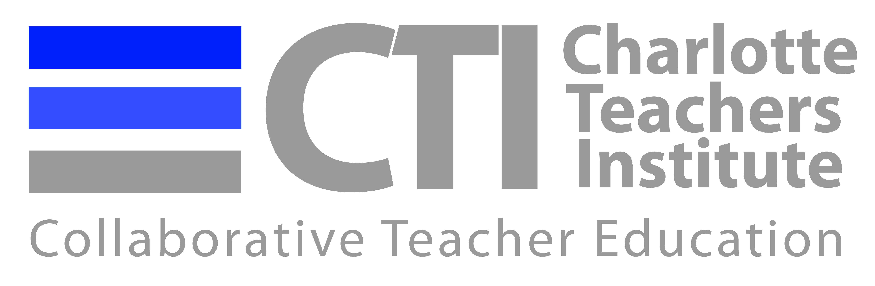

2016 CTI Curriculum Unit Prospectus Form

Your choice of a revised topic for your CU and proposed readings related to your topic should be based on an individual meeting with your seminar leader, as well as on your preliminary research and discussion with other Fellows in your seminar. The following information should be submitted to your seminar leader by Sunday, June 12.

Name of Fellow:

Revised Unit Topic (descriptive and concise):

Ideas for readings you might use for researching your topic:

Questions you have about resources you may need:

Please attach a Prospectus (2-4 pages) describing what you intend the unit to contain.

