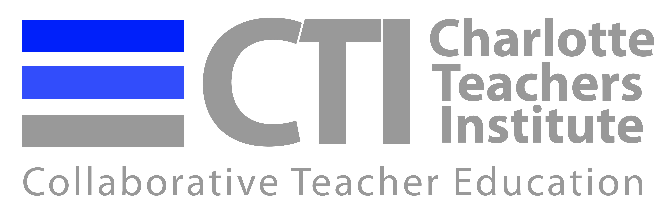

Timeline for Yale National Fellows 2015

January 14 – Attend CTI Leadership Meeting

January 19-28 – Complete and submit CTI application for Yale

February 2 – Attend Yale Virtual Open House

February 5– CTI Steering Committee meets to determine fellows to recommend

March 6 – Complete and submit National Fellow Application (copy and paste from CTI application for Yale)

March 6 – Principal Review Forms are due

April 1 – Yale Notification concerning selection

May 8-9 - Yale Organizational Session (travel May 7-10)

July 6-17 – Yale Intensive Session (travel July 5-18)

October 30-31 – Yale Annual Conference (travel October 29 - November 1)

*** You must be able to honor all of these dates for eligibility to apply ***

