The Finishing Touches
For your AMAZING CTI Curriculum Unit
So I wrote 15 pages…now what?

General Reminders
- Final CU due to Seminar Leader by 11/24
- Please do not be late…it’s Thanksgiving week
- Length:
  - Minimum of 15 pages (without cover sheet, appendices, bibliography and footnotes)
  - Maximum of 25 pages (with appendices, bibliography and footnotes -- cover sheet not included in page count)
- Complete your cover sheet (template is on your CTI flash drive) including key words, teaching standards, synopsis, and include it with your unit. Create a hyperlink on your cover sheet to the Teaching Standards Appendix 1 within your unit (see Handbook, p. 29 for instructions).

Formatting
- Single spaced
  - Copy and paste CU into “CTI CU Cover Sheet_FINAL_4-11-14” document on your CTI flash drive
  - Or format yourself…
Under “Paragraph” within Microsoft Word
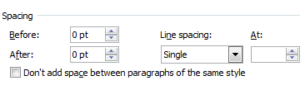

- 1.5’’ margins at top of page
- 1.25’’ margins on sides and bottom of page
- Bolded title, one space, author italicized, three spaces, begin paper

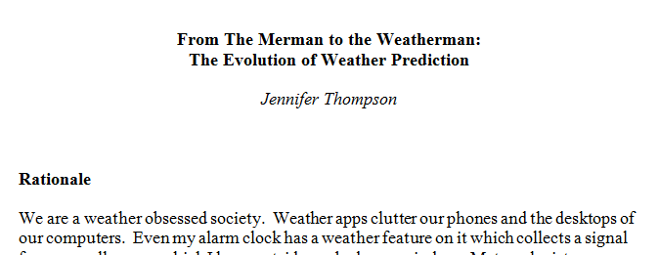

- Headings
  - Level-one: bold
  - Level-two: normal type
  - Level-three: italicized

- Space between each heading and paragraph

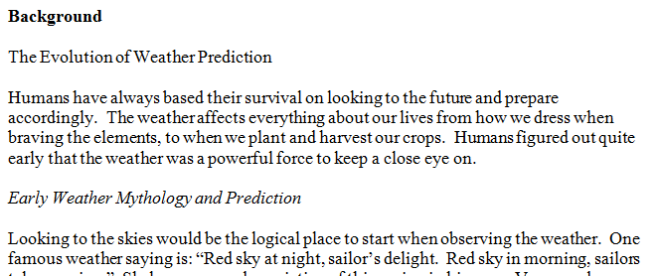

- First paragraph under heading do not indent
- All other paragraphs under heading indent 5 spaces
- Extra space between paragraphs

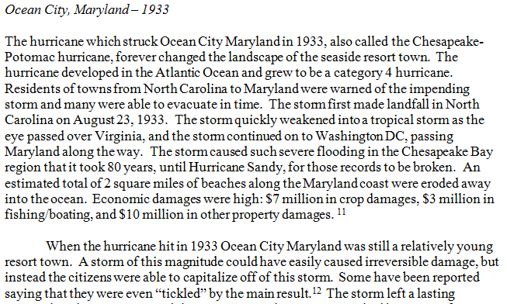

- No bullet points within the unit

Do this!!
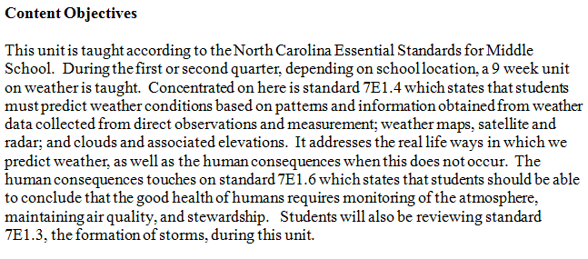
Not this!!
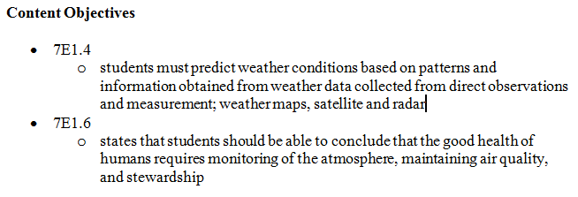
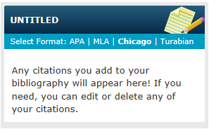
Citations
- Chicago style
- Bibme.org
  - Click on “Chicago” within right side menu
  - Choose type of source and mode of entry
  - Type information into correct fields
  - Finished citation will appear in box to right
  - Copy and paste into paper!


End Notes
- Endnotes, not footnotes
- Chicago style calls for entire citation within footnotes
- Times New Roman
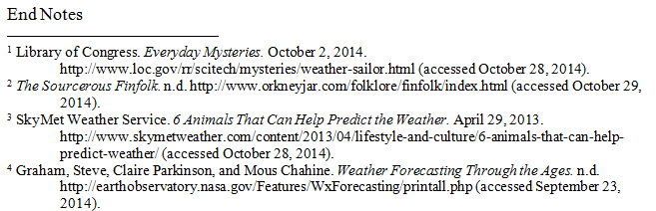

Bibliography
- Annotated bibliography
- 3 annotated lists: materials for classroom list, reading list for students, bibliography for teachers
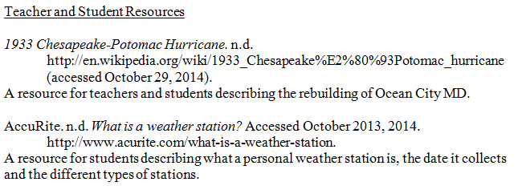
Appendix 1
- Appendix 1: Implementing Teaching Standards
- One page
- Briefly annotate academic standards
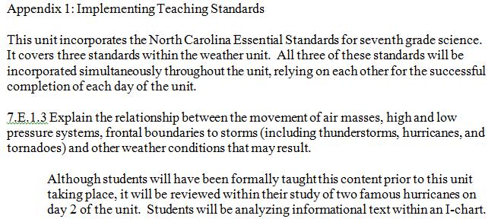

Submitting the unit…Yay!
- Email final unit to your Seminar Leader and info@charlotteteachers.org
- Attach TWO documents
  - Final unit plan - “JSmith_unit_11-24-14”
  - Appendix 1 - “JSmith_appendix1_11-24-14”
(Appendix 1 is also included inside your unit.)
- If you have to resubmit with changes/edits, simply resend updated unit with new date of submission (be sure to email copy to info@charlotteteachers.org).

Important Dates
- Monday 17th – Fellows Questionnaire sent out from Yale
- November 24th – Final CU due to Seminar Leader and info@charlotteteachers.org
- Friday 5th – Questionnaire due (both your CU AND questionnaire must be processed before you can receive your stipend)
- Thursday 11th – Fellows Finale Celebration! At the Bechtler Museum of Modern Art, 6:00 – 8:30 – Bring a guest, invite your principal. Celebrate!

