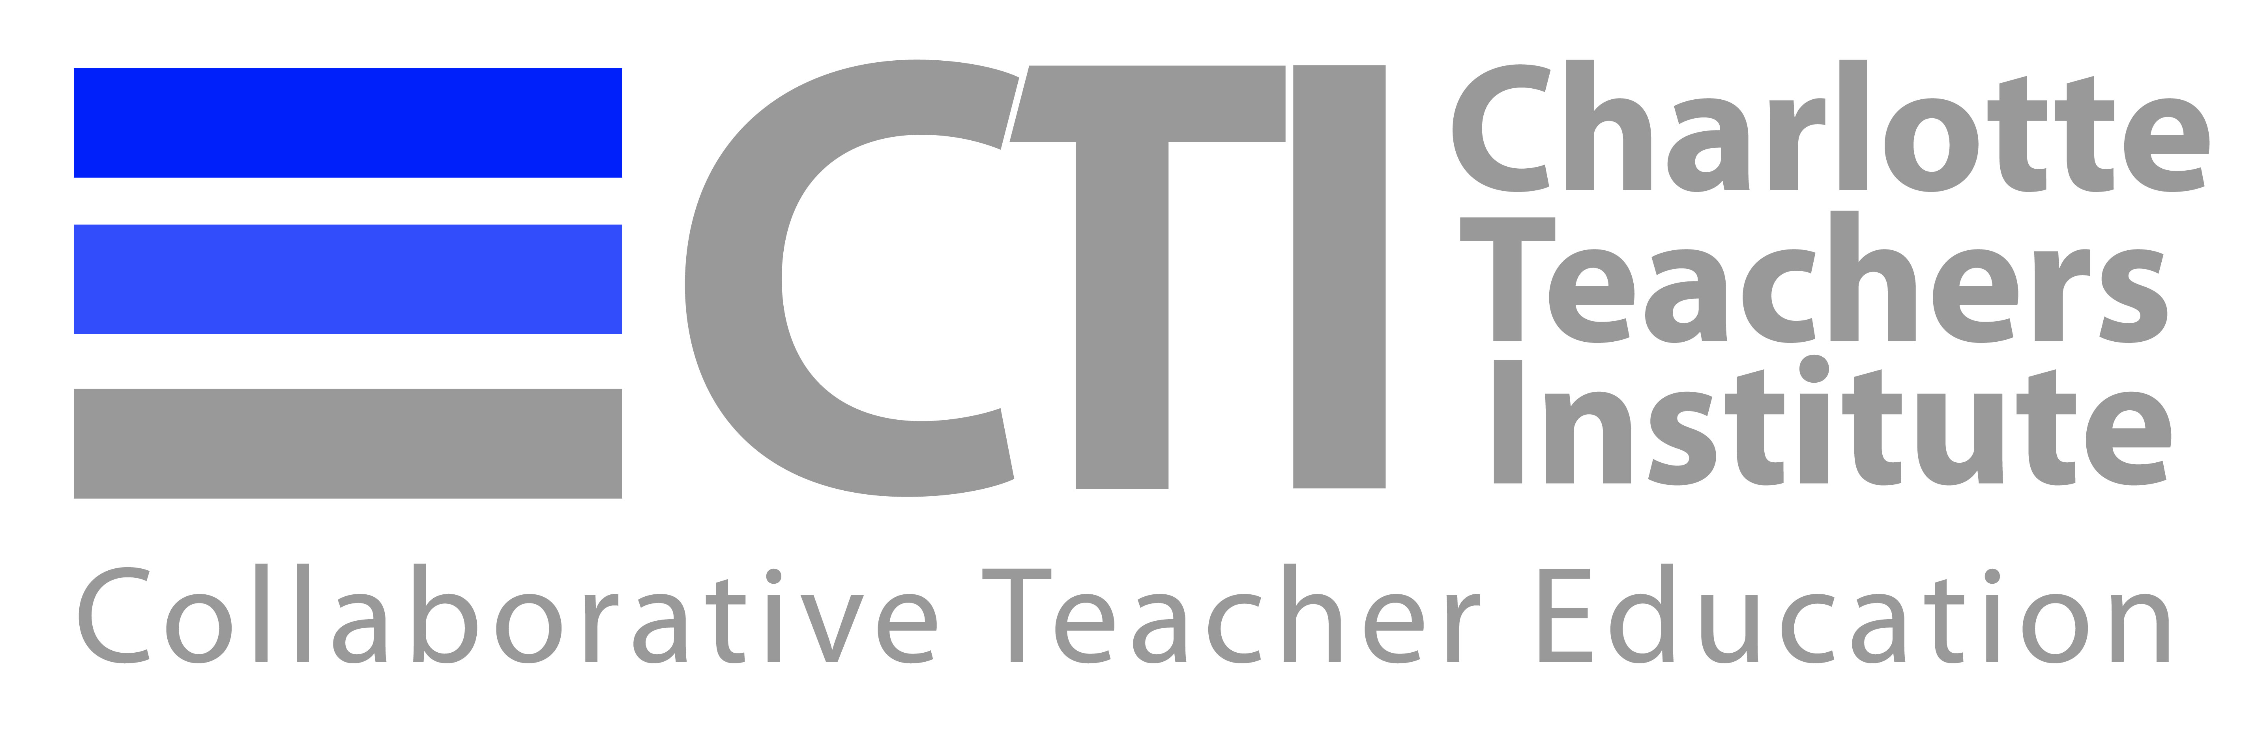
2014 Revised Unit Topic, Reading List and Prospectus Form
Your choice of a revised topic and readings should be based on an individual meeting with your seminar leader, as well as on your preliminary research and discussion with other Fellows in your seminar. The following information should be submitted to your seminar leader by Friday, June 13.

Name of Fellow:

Revised Unit Topic (descriptive and concise):

Ideas for readings you might use for researching your topic:

Questions you have about resources you may need:

Please attach a Prospectus (2-4 pages) describing what you intend the unit to contain.

